Name: |  |  |  | Telephone:
Address:
Email Address:
- Describe the research you have conducted to date and its significance:
- Describe your career plans and goals, including any research or clinical interests you may have developed. If known, please indicate the area(s) of medicine in which you are interested:
- List individuals with whom you would like to meet during your visit to Northwestern University:
- Please indicate the area(s) of subspecialty medicine you are most interested in pursuing:
Please list the individuals from whom you have requested letters of recommendation. One of these letters should be from your primary research supervisor or thesis advisor for applicants who have completed a PhD. At least one other individual should be familiar with your research.

Name | Phone Number | E-Mail Address

Please return the application and accompanying materials (including copies of all published papers) via email to:
 | 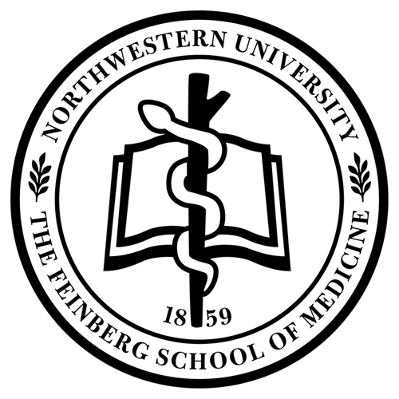
  Danny Bega, MD
  Residency Director
  Department of Neurology
  Feinberg School of Medicine
  danny.bega@nm.org
Puneet Opal, MD, PhD
PSTP Director
Department of Neurology
Feinberg School of Medicine
p-opal@northwestern.edu

